(Approx. 1049 words)
QR Codes and More
Barcodes containing useful info now show up in videos and presentations. Learn how to use those barcodes.
By John Krout, Writer/Presenter, Potomac Area Technology and Computer Society
www.patacs.org
krout75 (at) yahoo.com

A QR code is a square 2-dimensional barcode that provides useful info such as a web page address (URL). QR codes can also contain email addresses, contact info, and just about any text. It is not the only square barcode out there. QR codes can be recognized by the square target blocks in the top two and bottom left corners.
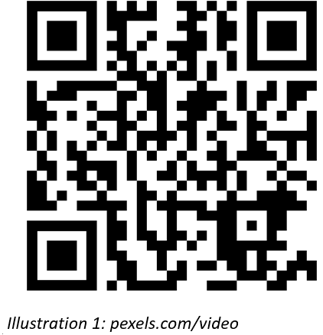
Illustration 1 shows a QR code example. This particular QR code provides a web page address for a site where short user-created videos can be downloaded for free. You have probably seen square QR code barcodes many other times in recent years.
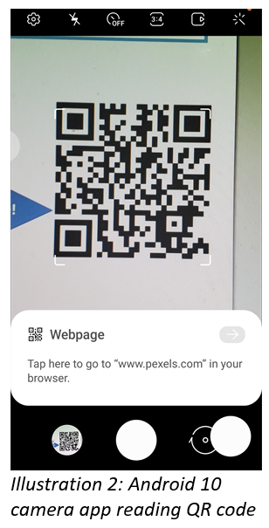
My presentations for PATACS frequently include web page addresses. In this pandemic era of virtual meetings, I have decided to include not only the actual URL but also the QR code containing the URL.
Anyone in the audience who wants to copy the URL from the presentation immediately can do so simply by using their smartphone. Chances are that you won't even need to install a barcode reader app on your phone. In recent iPhones and Android 10 phones, the camera app has been augmented to act as a QR code reader.
I tried my Samsung Galaxy S10 camera app. I pointed it at the computer screen where a QR code was visible in one corner of a presentation. The camera app immediately displayed the web page URL contained in the QR code, as you can see in Illustration 2. I did not even have to snap a photo of the QR code. The app gave me the option of tapping the address to open that web page. Opening the web page is ideal for quickly saving the URL for later bookmarking.
Many retailers post QR codes enabling you to learn more about products.
MUNZEES
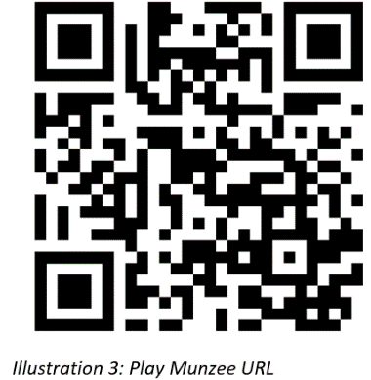
There is an outdoor game based on QR codes printed on small stickers posted outdoors. The name of the game is Munzees. I have not tried the game, though I know a few of my geocaching friends also play Munzees, and occasionally I see the small Munzees QR code stickers outdoors. Any small QR code in a place where it does not seem to identify any product or other specific object is quite possibly a Munzees QR code.
The Munzees game has its own website, www.playmunzee.com, and its own free phone app for communicating found Munzee QR codes to the website. That URL is encoded in Illustration 3.
CREATING QR CODES
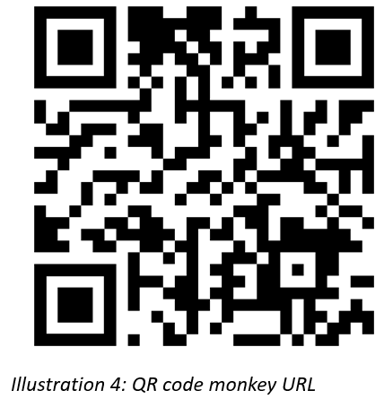
I found that my Galaxy 10 Contacts app will generate a QR code for any record in my Contacts list. When I create a contact QR code, it appears on the phone screen. At that point, I can save the QR code as a graphics image file, or attach it to an email or a text message.
There is a website, https://www.qrcode-monkey.com/, which creates QR codes containing the info you provide. It provides some interesting features, such as multi-color QR codes and placement of a recognizable logo in a QR code. You can download, save, print, and share any QR code you generate on that site. The site provides this service for free. That URL is encoded in Illustration 4.
OTHER TYPES OF BARCODES
There are several types of barcodes in wide use.
The Uniform Product Code (UPC) barcode on products, which enables rapid checkout and helps the retailer manage inventory, encodes information in several parallel vertical bars. That is an example of a 1-dimensional (1D) barcode. There are phone apps designed to scan UPC codes and tell you if the same product can be found for a lower price elsewhere.
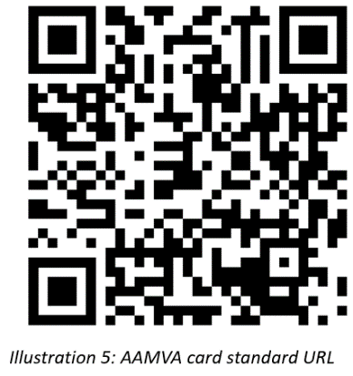
If you have a driver's license, it contains both a 1D barcode and a 2-dimensional (2D) barcode. That 2D barcode is a type called PDF-417, and it includes all the text info on your license as well as some other info identifying your license record in the Virginia computer system. The American Association of Motor Vehicle Administrators (AAMVA) created a standard for contents of the driver's license 2D barcode and updates the standard every few years. That standard is available online as a PDF document. You can read the field definitions in section D.12.5 of the PDF posted at the following URL, which is encoded in Illustration 5.
https://www.aamva.org/aamva2020dlidcarddesignstandard/
The 2D barcode on the driver's license is now scanned by Safeway at checkout if you buy alcohol. That means the Safeway computer system may capture a great deal of info other than your date of birth. Does the company save all that additional info about you? Doing so centrally would use up a gigantic amount of storage space. Possibly the stores store the info locally, on a store server. That localized info could be valuable if a company store is audited by Virginia ABC for underage sales.
Barcodes also typically show up on shipment box labels.
United Parcel Service uses a 1D barcode type for machine-readable package tracking numbers. If you have received UPS parcels in person, you have probably seen the UPS driver use a barcode scanner to scan the tracking number barcode and confirm the date and time of delivery of the parcel.
While the phone camera apps will read only QR codes, other free apps can be used to read a variety of barcodes. I downloaded one Android with the rather generic name Barcode Scanner to read the Virginia driver's license barcode. The same app reads QR codes, UPC codes, PDF-417 codes, CODE 39 (1D barcode type, which appeared above the address in correspondence I received from the Arlington County Government), Data Matrix (another square 2D barcode type), and some other types. I used that app to read the PDF-417 barcode on my Virginia driver’s license.
ABOUT THE AUTHOR: ABOUT THE AUTHOR: John Krout has been writing about creative uses of personal computers since the early 1980s. Until April 2020 he was a software documentation writer, contracted to support a major federal government computer system. Now he lives on his IRA and writes whatever he wants to. He resides in Arlington Virginia with his son, many computers and cameras, and too many cats.

